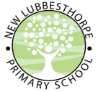
Friday 12th April
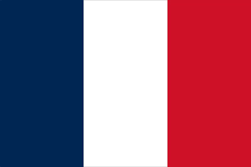
Summer Term Creative Homework: Study of France

This homework is due: Wednesday 3rd July – Friday 5th July
During Summer Term, please complete the creative homework to enhance your wider curriculum learning. This term we are focussing on France and the French Language. On Friday 5th July we will hold an after-school Summer Fayre with the theme ‘France’ where we will showcase the homework pieces submitted by the children.
We have been blown away by the creative homework made so far this year, thank you for your hard work! As a slight change to previous creative homework’s, this time we’d love for you to choose any theme/idea from the box below and create something linked to it; additionally, you could choose something not listed too so long as you can link it to France.
France / French Language Creative Homework Ideas
- The French Flag
- French History / Timeline
- French Cuisine / Foods / Drinks (you could even bake something and bring it in!)
- Famous people from France
- The French language
- French Sports / Sports Teams
- The 2024 Olympics
- French Music / Musicians
- French Artwork / Artists
- French Stories / Poems / Books / Authors
- French Clothing/Fashion
- French Geography (cities/maps/holidays)
- Famous French Buildings (you could make, draw or research them)
- French Language around the world
- Disneyland France
- French Vehicles/Cars
- Tour de France
- French Entertainment / TV shows / Movies
*this is creative homework, therefore there is no set way we expect the work to be produced, it is entirely the children’s choice for how they choose to complete their science project and what it will be on. Be as creative as you can with this!
If you have any questions please ask your class teacher.
We look forward to seeing what you create!

